Conditional Loops

1. Find the sum of first n prime numbers.

forPrime.sh

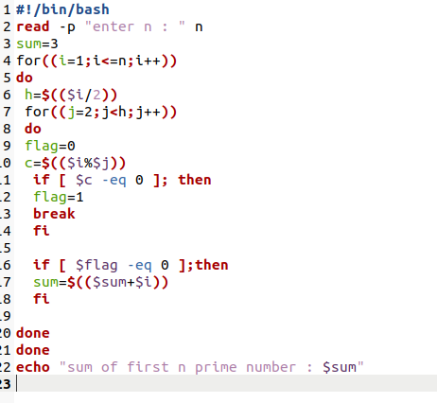

Terminal

